**DR. BABASAHEB AMBEDKAR TECHNOLOGICAL UNIVERSITY, LONERE 402103**



**PROJECT REPORT**

on

**“SORTING VISUALIZER USING JAVASCRIPT”**

PRESENTED BY

|  |  |  |
| --- | --- | --- |
| **Sr No** | **Student Name** | **PRN** |
| **1.** | Aishwarya Anand Kumbhar | **2067571242015** |
| **2.** | Rutuja Arjun Mane | **2067571242013** |
| **3.** | Aarti Madhukar Palande | **2067571242020** |
| **4.** | Muskan Hanif Shaikh | **2067571242007** |

UNDER THE GUIDANCE OF

**Dr. Balshetwar S. V.**



**DEPARTMENT OF COMPUTER SCIENCE AND ENGINEERING**

YASHODA TECHNICAL CAMPUS, WADHE, SATARA



# DEPARTMENT OF COMPUTER SCIENCE AND ENGINEERING

Certificate

# This is to certify that the project entitled “SORTING VISUALIZER USING JAVASCRIPT” is prepared and submitted by

|  |  |
| --- | --- |
| **1.** Aishwarya Anand Kumbhar | **2067571242015** |
| **2.** Rutuja Arjun Mane | **2067571242013** |
| **3.** Aarti Madhukar Palande | **2067571242020** |
| **4.** Muskan Hanif Shaikh | **2067571242007** |

**Students of B.Tech (COMPUTER SCIENCE AND ENGINEERING), in partial fulfillment of the requirements for the award of Bachelor of Technology in Computer Science and Engineering as prescribed by the Dr. Babasaheb Ambedkar Technological University, Lonere at Yashoda Technical Campus during academic year 2022-2023.**

# PROJECT GUIDE HOD

**Dr. Balshetwar S. V. Dr. Balshetwar S. V.**

# PROJECT CO-ORDINATOR PRINCIPAL

## Prof. Jagtap K. P. Dr. Badadpure P. R.

**DECLARATION**

We hereby declare that the project work entitled SORTING VISUALIZER USING JAVASCRIPT submitted to the Yashoda Technical Campus’s College of Engineering, Satara is a record of an original work done by us under the guidance of our project guide **Dr. Balshetwar S. V.** and this project work is submitted in the partial fulfillment of the requirements for the award of the degree of Bachelor of Technology in Computer Science & Engineering. This project report has not been copied, duplicated or plagiarized from any other paper, journal, document or book and has not been submitted to any educational institute or otherwise for the award of any certificate, diploma, degree or recognition.

## ACKNOWLEDGEMENT

We take this opportunity to express our deep sense of gratitude to our guide, **Dr. Balshetwar S. V.** for her continuous guidance and encouragement during this study. Without her valuable suggestion and encouragement this would not have been possible. It is because of her experience and wonderful knowledge we can fulfill the partial requirement of completing the Field Training report within the stipulated time.

We express our deep gratitude to **Dr. Balshetwar S. V.** Head of Computer Engineering Department, for his valuable guidance and constant encouragement. We are very much thankful to **Dr. Badadpure P. R.** Principal, YSPM’s Yashoda Technical Campus, Faculty of Engineering, Satara. We find our self- spellbound to acknowledge thanks to our father and mother for their silent support, patience, encouragement and affection without which this work would never have been possible and we thank all my colleagues for their valuable co- operation and coordinate which was available time to time.

# Project Index

|  |  |  |
| --- | --- | --- |
| **INDEX** | | |
| **Chapter No** | **Description** | **Page No.** |
|  | **CERTIFICATE** | I |
|  | **DECLARATION** | Ii |
|  | **ACKNOWLEDGEMENT** | Iii |
|  | **PAPER PUBLICATIONS** | Iv |
|  | **ABSTRACT** | V |
|  | **INDEX** | Vi |
|  | **LIST OF TABLES** | Vii |
|  | **LIST OF FIGURES** | Viii |
| **1** | **INTRODUCTION** | 9 |
| 1.1 | Motivation |  |
| 1.2 | Project Overview |  |
| 1.3 | Need of project |  |
| 1.4 | Literature survey (at least 5) | 10 |
| **2** | **PROBLEM DEFINITION & SCOPE** | 12 |
| 2.1 | Problem statement |  |
| 2.2 | Scope |  |
| 2.3 | Area of project |  |
| 2.4 | Goals & objectives |  |
| **3** | **SOFTWARE REQUIREMENT SPECIFICATION** | 13 |
| 3.1 | Software requirement |  |
| 3.2 | Hardware requirement |  |
| **4** | **PROJECT PLAN** | 14 |
| 4.1 | Project schedule |  |
| 4.2 | Project cost estimation |  |
| 4.3 | SDLC |  |
| 4.4 | Feasibility Study |  |
| **5** | **SOFTWARE DESIGN** | 17 |
| 5.2 | Flow chart |  |
| 5.4 | Use Case Diagram |  |
| 5.5 | Activity Diagram |  |
| 5.6 | System Architecture |  |

|  |  |  |
| --- | --- | --- |
| **6** | **IMPLEMENTATION DETAILS** | 22 |
| 6.1 | Modules and Their Functionalities |  |
| **7** | **SYSTEM TESTING** | 23 |
| 7.1 | Interface Testing |  |
| 7.2 | Performance Testing |  |
| 7.3 | Compatibility testing |  |
| **8** | **SNAPSHOTS/ GUI** | 24 |
| **9** | **CONCLUSION** | 31 |
| **10** | **BIBLIOGRAPHY** | 32 |

**LIST OF TABLES**

|  |  |  |
| --- | --- | --- |
| **Table No.** | **Title** | **Page No.** |
| 1.4 | Literature Survey | 10 |
| 4.1 | Project Plan | 14 |
| 4.2 | Project Cost Estimate | 14 |

# LIST OF FIGURES

|  |  |  |
| --- | --- | --- |
| **Figure No.** | **Title** | **Page No.** |
| 4.1 | Project Schedule | 14 |
| 5.1 | Data Flow Diagram   * + 1. : DFD Level 0     2. : DFD Level 1 | 17 |
| 5.2 | Flow Chart | 18 |
| 5.3 | Use-Case Diagram | 19 |
| 5.4 | Activity Diagram | 20 |
| 5.5 | System Architecture | 21 |
| 8.1 | Home Page | 24 |
| 8.2 | Bubble Sort  8.2.1 Bubble Sort  8.2.2 Enter Elements Of Array  8.2.3 Generated Bar  8.2.4 Comparison Between Elements  8.2.5 Swapping Between Elements  8.2.6 Previous Sort  8.2.7 Successfully Sorted | 25 |
| 8.3 | Insertion Sort | 28 |
| 8.4 | Selection Sort | 29 |
| 8.5 | Quick Sort | 29 |
| 8.6 | Merge Sort | 30 |

1. **INTRODUCTION**

## Motivation:-

The motivation behind this project is to study how the operations on data structure are performed. So that students can learn various algorithms through animation.To get a clear knowledge about various data structures and their operations on it. It will makes data structures learning more interesting. The main goal of this project is to implement a system for various sorting algorithm. User run sorting algorithm by giving custom array.During the demonstration run, the application visualizes pseudo code and current informationabout some variables.

## Project Overview:-

This project is a study that tested the benefits of animated sorting algorithms for teaching. To visualize sorting algorithms, a web-based animation application was constructed. Aim behind implementation of this project to make a clear understanding ability of various algorithms of data Structure.

Using a web page this will simulates the Sorting algorithm of data structure such as Bubble Sort, selection sort, radix sort. And so on. Thus our web page provides effective and efficient knowledge of data structures.

It is web-based application for visualize different sorting algorithm with their functionality of:

* + - Input array size – Here user can take input array
    - Stop Button - To Stop Sorted Visualized algorithm
    - Resume - To Resume Sorting Visualized algorithm
    - Reset - To Reset Sorted Visualized algorithm
    - Clear - To Clear Sorted Visualized algorithm

This also provides some theoretical knowledge regarding the data structure.

## Need Of Project:-

As we know Data structure and algorithms (DSA) are one of the important topic in technology field and along with that one more crystal truth is that each and every student goes through each concept of DSA but student get confused and DSA getting hard to understand for students because of everyone do programming but didn't know how it will be working so In this projectwe will take one concepts that is sorting algorithm and off course we implement it and by using animations and visualization it will be helpful for students to understand that how actually sortingmethods like bubble sort, selection sort, insertion sort, merge sort and so on works.

## Literature Survey:

**-**

|  |  |  |  |  |
| --- | --- | --- | --- | --- |
| Sr. No. | Paper | Year | Author | Review |
| 1. | A system for algorithms' animation | 1999 | D. Merlini, S. Petruzzi, R. Sprugnoli and  M. C. Verri | Data structure related complicated concept are diificult to understand for student. So, visualization technique helps teacher to teach them very easily  Sorting algorithm show user input data through animation. This tool shows sorted data and unsorted data with different color. It helps student to understand, how data can be sorted dynamically. |
| 2. | DAVE: A Dynamic Algorithm Visualization Environment for Novice Learners | 2008 | E. Vrachnos  and A.  Jimoyiannis | Sorting algorithm represent sorted array through animation. This tool shows sorted data and unsorted data with different color. It helps student to see how sorting function actually work to sort data at backend |
| 3. | Sorting Algorithm visualizer | 2022 | Thakkar, Kavita, S. Dash and S. K. Joshi | It is E-learning platform which helps toimprove theoretical concept regarding Data structure and algorithm.  Data can be represented by Bar graph, and then sorting algorithm may be apply on that.  In Sorting Visualizer, take input data from user and show that data as bar graph. Then choose animation tool and after that algorithm can be apply on it. |
| 4. | Algorithm Visualizer: Its features and working | 2021 | Goswami, A. Dhar, A. Gupta and A. Gupta | Some learners can’t understand theory with clarity. From this work student can visualize several algorithms and learn new concepts. This visualizer is easy to operate and implement. It contain stepwise representation of visualization of algorithm which makes it easy to understand. |
| 5. | Creating Engaging Online Learning Material with the JSAV JavaScript Algorithm Visualization Library | 2016 | V. Karavirta  and C. A. Shaffer | DSA is complicated to learn for most of the students. Learners can improve their DSA topics with JavaScript Algorithm Visualization. In this contain JavaScript Algorithm Visualization library. This library helps to visualize data structures algorithms. Learners can see previous step of visualization with actual current step. |

|  |  |  |  |  |
| --- | --- | --- | --- | --- |
| 6. | Visualizing Sequence of Algorithms for Searching and Sorting | 2009 | [Bremananth](https://ieeexplore.ieee.org/author/37085572475) [R.,Radhika](https://ieeexplore.ieee.org/author/37085572475) [V.Thenmozhi](https://ieeexplore.ieee.org/author/37085936234) [S.](https://ieeexplore.ieee.org/author/37085935579) | Visualizing sequence of algorithm for searching and sorting in this paper. It help to understand how perform the sorting method in easy way. The main pros of algorithm visualization is acquire the knowledge through performing with set of data, technique of manage time and use of memory. It shows nine type of sorting algorithm form this one of animataion system is BALSA(Brown Algorithm and animator). |
| 7. | Interactive visualization of high dimensional marketing data | 2015 | [Alfa Yohannis](https://ieeexplore.ieee.org/author/38111029100) [Yulius](https://ieeexplore.ieee.org/author/37085465263) [Prabowo](https://ieeexplore.ieee.org/author/37085465263) | Interactive visualization, it is used to associate all types of variable and also describe visualization of huge amount of data for financial organization. We use matrix visualization as a selection tool, its simple for find the data. The client select data of selected variable and start a analysis by using 5 variable. Using this we give good customer behavior knowledge. |
| 8. | Sorting visualization using ViSA (visualization  of sorting algorithm | 2012 | Tihomir Orehovački | In this paper, ViSA (Visualization of sorting algorithm) it discribe a tool and different type of technique for visualization of algorithm. The ViSA is simple and self operating visualization system, it explain and compare step by step every sorting algorithm which is more useful to every educational student for analyze the sorting algorithm also for faculty  member for teaching. |
| 9. | Sort Attack: Visualization and Gamification of Sorting Algorithm Learning | 2015 | [Alfa Yohannis,](https://ieeexplore.ieee.org/author/38111029100) [Yulius](https://ieeexplore.ieee.org/author/37085465263) [Prabowo](https://ieeexplore.ieee.org/author/37085465263) | Sorting algorithm is perform fundamental role in the field of computer science, which are not understandable toeveryone to defeat this problem it has been moving toward the game visualization. The combining algorithm gaming tool and instructional or graphical design is an minor task, so it require attentive design, because of that it developed conceptual model for learning instruction and  improve visualization learning. |
| 10. | Comparative of Advanced Sorting Algorithms Based on Time and Memory Usage | 2021 | [Marcellino](https://ieeexplore.ieee.org/author/37089379788) [Marcellino,](https://ieeexplore.ieee.org/author/37089379788) [Davin William](https://ieeexplore.ieee.org/author/37089379977) [Pratama](https://ieeexplore.ieee.org/author/37089379977) [Kristien Margi](https://ieeexplore.ieee.org/author/37089380629) | In this paper, it compare different type of advance sorting algorithm such as Quick sort, Heap sort, Merge sort, introspective sort. A algorithm compare on the bases of time and memory require to perform data sorting.  Application write using VS code and satisfy using python language. In this it show introspective sort good at time and heap sort is good for memory. |

**1.4: Literature Review**

# PROBLEM DEFINATION AND SCOPE

## Problem Statement:-

Aim behind implementation of this project to make a clear understand ability of various algorithms of data structures. Using a web page this will simulates the Sorting algorithm of data structure such as sorting such as bubble sort, selection sort, radix sort. Thus our web page provides effective and efficient knowledge of data structures.

It is web based application for visualize different sorting algorithm with their functionality of speed control, Array size control. This also provide some theoretical knowledge regarding the data structure.

## Scope: -

The main goal of this project is to create teaching support software with

visualization of the most known sorting algorithms and their variations. The application supports a graphic visualization of selected algorithms on randomly generated or manually created array, step-by-step execution possibility, pseudo code and current state of variables.

## Area Of Project: -

**Web based application**

A web application is application software that is accessed using a web browser. Web applications are delivered on the World Wide Web to users with an active network connection.

A Web application (Web app) is an application program that is stored on a remote server and delivered over the Internet through a browser interface.

## Goals and Objectives: -

The main objective of this project is to help beginners to be able to visualize the basic algorithms and get a better understanding of the underlying operations.

* + - Creativity in making the visualizations even better and attractive.
    - This project is for educational purpose.

# SOFTWARE REQUIREMENT SPECIFICATION

## Hardware Requirements

Processor: core i3 Hard disk: 5 GB Memory: 1 GB RAM

* 1. **Software Requirements** Browser: Chrome, Mozilla Firefox IDE: Visual Studio Code Frontend: HTML, CSS

# PROJECT PLAN

## Project Schedule

|  |  |  |  |  |  |  |  |  |  |  |  |
| --- | --- | --- | --- | --- | --- | --- | --- | --- | --- | --- | --- |
|  | Aug | Sept | Oct | Nov | Dec | Jan | Feb | Mar | Apr | May | Jun |
| Discussion With Guide |  |  |  |  |  |  |  |  |  |  |  |
| Planning |  |  |  |  |  |  |  |  |  |  |  |
| Research |  |  |  |  |  |  |  |  |  |  |  |
| Synopsis |  |  |  |  |  |  |  |  |  |  |  |
| Discussion With Guide |  |  |  |  |  |  |  |  |  |  |  |
| Implementation |  |  |  |  |  |  |  |  |  |  |  |
| Testing |  |  |  |  |  |  |  |  |  |  |  |
| Submission |  |  |  |  |  |  |  |  |  |  |  |

Fig 4.1 Project Schedule

## Project Cost Estimation

|  |  |  |  |
| --- | --- | --- | --- |
| **Sr. No** | **Project Stage** | **Formulae used** | **Effort in Days** |
| 1 | Planning | 20 percent of Project Life Cycle effort | 20 Days |
| 2 | Requirement Gathering Requirement Analysis Design | 80 percent of Project Life Cycle effort | 90 days |
| 3 | Development Or Coding Effort | 25percent of Project Life Cycle effort | 30 days |
| 4 | Testing | 20 percent of Project Life Cycle effort | 23 days |
| 5 | Project Management Effort | 25 percent of Project Life Cycle effort | 29 |
| 6 | User Testing | 20 percent of Project Life Cycle effort | 23 |
| Total No of days Effort Required | |  | 1. days |

Fig4.2: Project Cost Estimation

Number of Hours Per Day: 3 Hours Totals Hours Required: Hours * Days

3 * 215

Totals Hours Required: 645 Hours

Cost per hour: 81Rs Total cost: 645*81 Total cost: 52,245Rs

**4.3 SDLC**

Software Development Life Cycle (SDLC) is a process used by the software

industry to design, develop and test high quality software. The SDLC aims to produce high- quality software that meets or exceeds customer expectations, reaches completion within times and cost estimates.

* + - SDLC is the acronym of Software Development Life Cycle.
    - It is also called as Software Development Process.
    - SDLC is a framework defining tasks performed at each step in the software development process.
    - ISO/IEC 12207 is an international standard for software life-cycle processes. It aims to be the standard that defines all the tasks required for developing and maintaining software.

## SDLC: -Agile Model:

Agile SDLC model is a combination of iterative and incremental process models with focus on process adaptability and customer satisfaction by rapid delivery of working software product. Agile Methods break the product into small incremental builds. These builds are provided in iterations. Each iteration typically lasts from about one to three weeks. Every iteration involves cross functional teams working simultaneously on various areas like −

* + - Planning
    - Requirements Analysis
    - Design
    - Coding
    - Unit Testing and Acceptance Testing.

At the end of the iteration, a working product is displayed to the customer and important stakeholders.

## 4.4:Feasibility Study: -

A feasibility study evaluates a project's or system's practicality. As part of a feasibility study, the objective and rational analysis of a potential business or venture is conducted to determine its strengths and weaknesses, potential opportunities and threats, resources required to carry out, and ultimate success prospects. Two criteria should be considered when judging feasibility: the required cost and expected value.

A feasibility study is a comprehensive evaluation of a proposed project that evaluates all factors critical to its success in order to assess its likelihood of success. Business success can be defined primarily in terms of ROI, which is the amount of profits that will be generated by the project.

## Operational Feasibility

This assessment involves undertaking a study to analyze and determine whether—and how well—the organization’s needs can be met by completing the project. Operational feasibility studies also examine how a project plan satisfies the requirements identified in the requirements analysis phase of system development.

## Scheduling Feasibility

This assessment is the most important for project success; after all, a project will fail if not completed on time. In scheduling feasibility, an organization estimates how muchtime the project will take to complete.

# SOFTWARE DESIGN

## Data Flow Diagram:

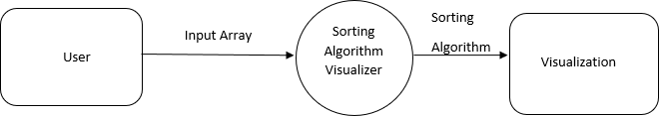

Fig 5.1.1: DFD Level 0

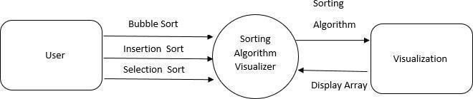

Fig 5.1.2: DFD Level 1

## : Flow Char

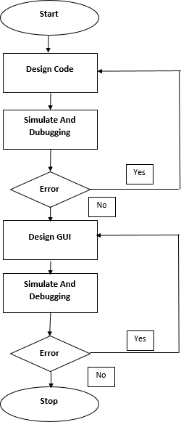

Fig 5.2: Flow Chart

## 5.3: Use Case Diagram:

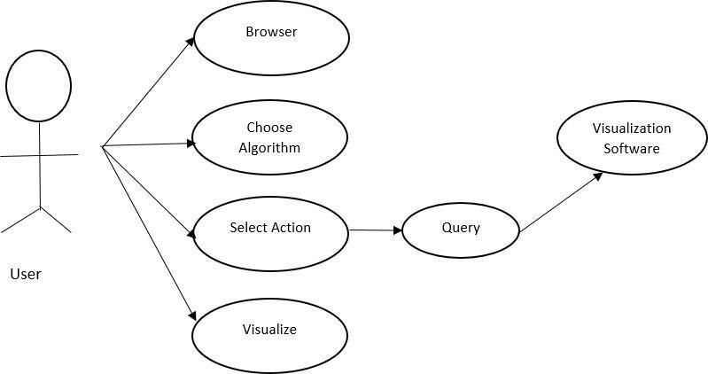

Fig 5.3: Use Case Diagram

## 5.4: Activity Diagram:

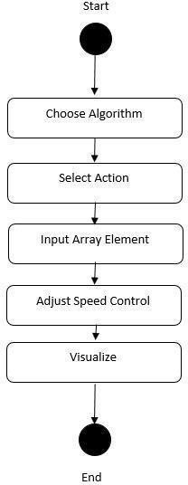

Fig 5.4: Activity Diagram

## 5.5: System Architecture

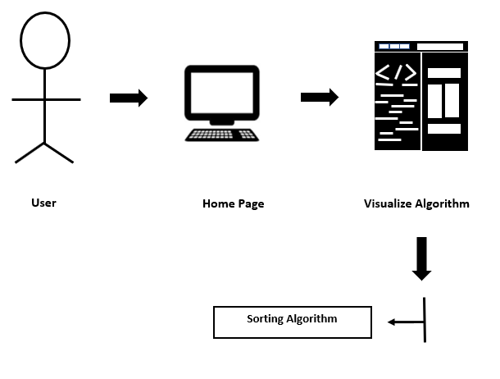

Fig 5.5: System Architecture

# IMPLEMENTATION DETAILS

## Modules and their functions:

* + - **Home Page:**

User can see various sorting algorithm and its abstract information.

* + - **Bubble Sort Page:**
      * Input array size – Here user can take input array
      * Stop Button - To Stop the bubble sort visualized algorithm
      * Resume - To Resume bubble sort visualized algorithm
      * Reset - To Reset bubble sort visualized algorithm
      * Clear - To Clear bubble sort visualized algorithm
    - **Insertion Sort Page:**
      * Input array size – Here user can take input array
      * Stop Button - To Stop the insertion sort Visualized algorithm
      * Resume - To Resume the insertion sort Visualized algorithm
      * Reset - To Reset the insertion sort Visualized algorithm
      * Clear - To Clear the insertion sort Visualized algorithm

**Designing:**

For proper visualization we have used different colours to differentiate between the sorted bars and unsorted bars and even for bars which are currently in the process of comparison and sorting.After sorting the colours of bars will change to same colour which will be different from initial colours of array and array elements will be arrange in ascending order.

# SYSTEM TESTING

## What is Web Testing?

Web Testing, or website testing is checking your web application or website for potential bugs before its made live and is accessible to general public. Web Testing checks for functionality, usability, security, compatibility, performance of the web application or website.

## Interface Testing:

Three areas to be tested here are – Application, Web and Database Server

Application: Test requests are sent correctly to the Database and output at the client side is displayed correctly. Errors if any must be caught by the application and must be only shown to the administrator and not the end user.

Web Server: Test Web server is handling all application requests without any service denial. Database Server: Make sure queries sent to the database give expected results.

## Performance Testing:

This will ensure your site works under all loads. Software Testing activities will include but not limited to –

Website application response times at different connection speeds

Load test your web application to determine its behaviour under normal and peak loads.

Stress test your web site to determine its break point when pushed to beyond normal loads at peak time.

## Compatibility testing:

Compatibility tests ensures that your web application displays correctly across different devices. This would include-

Browser Compatibility Test: Same website in different browsers will display differently. You need to test if your web application is being displayed correctly across browsers, JavaScript, AJAX and authentication is working fine. You may also check for Mobile Browser Compatibility.

# SNAPSHOTS / GUI

## Home Page:

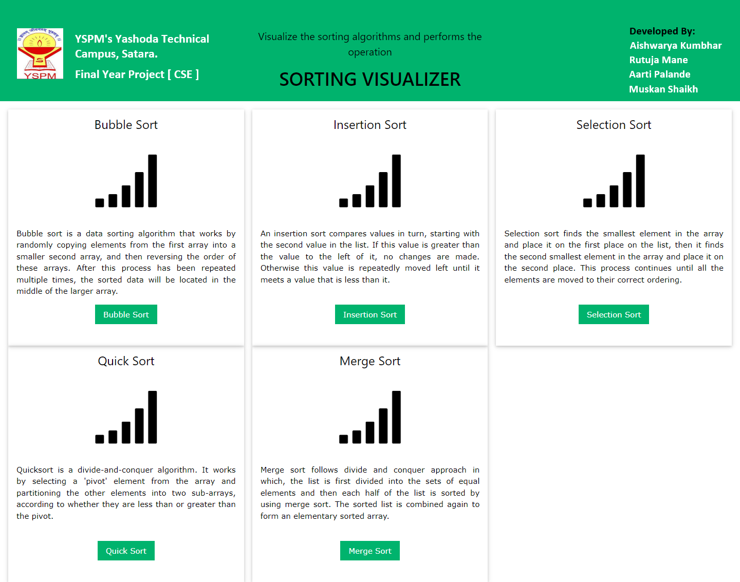

Fig 8.1. Home Page

## Bubble Sort:

## 

Fig 8.2.1 Bubble Sort

## Enter Elements of Array:

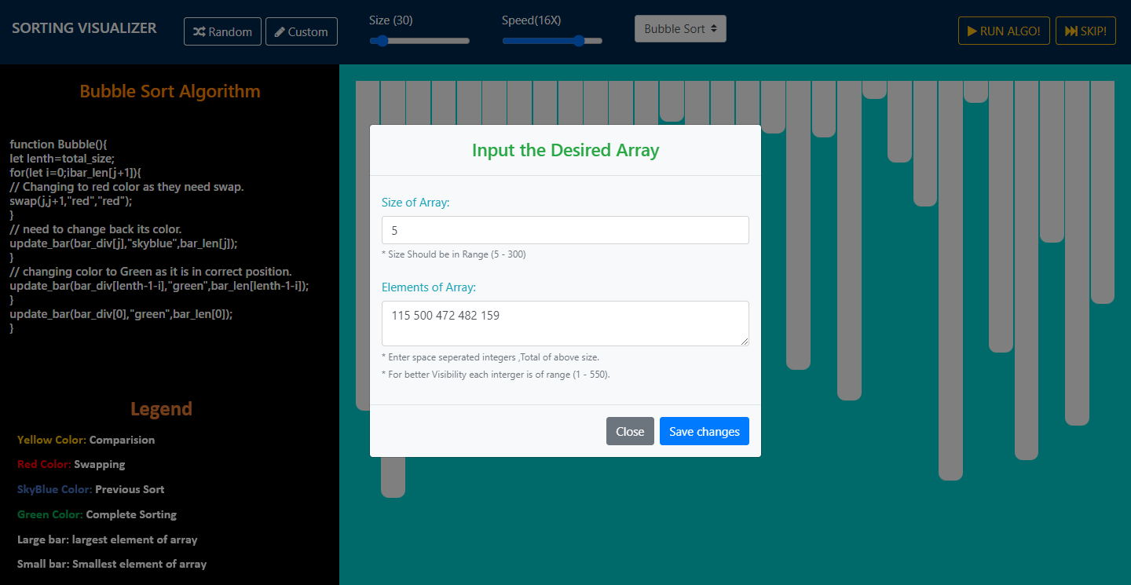

Fig 8.2.2 Enter Bubble Sort Elements

## 8.2.3 Generated Bars:

## 

Fig 8.2.3 Generated Bars

**Output**

**8.2.4 Comparison Between Elements:**

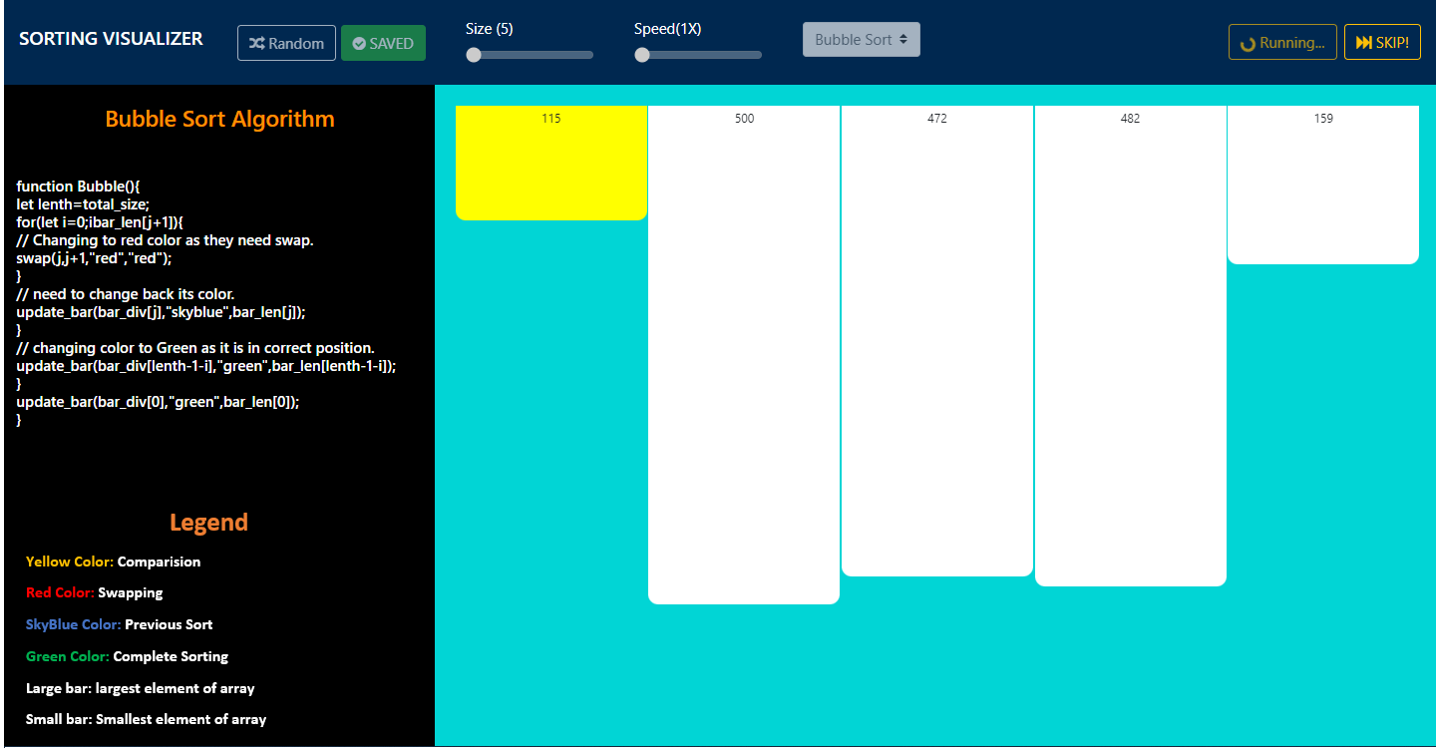

Fig 8.2.4 Comparison Between Elements

**8.2.5 Swapping Between Elements:**

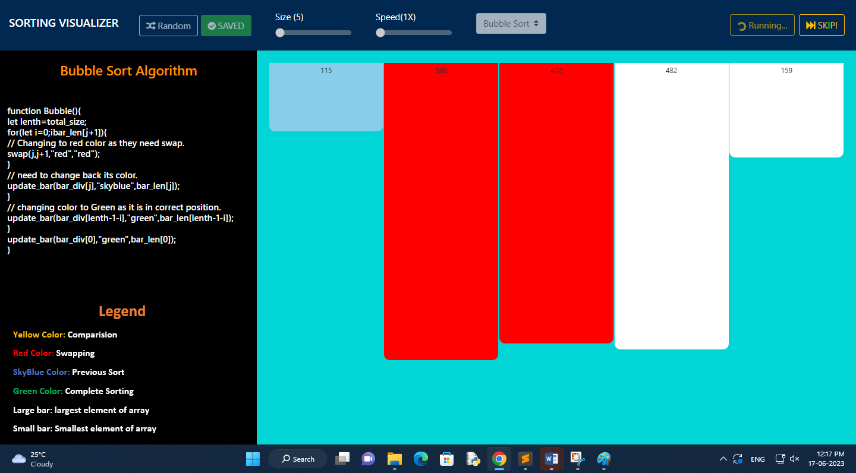

Fig 8.2.5 Swapping Between Elements

**8.2.6 Previous Sort:**

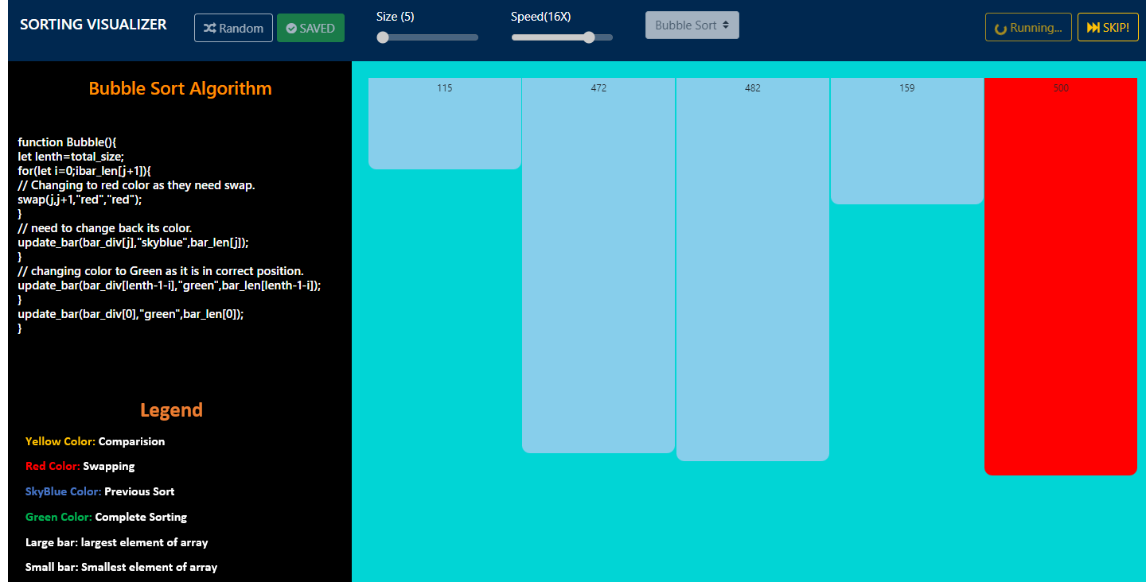

Fig 8.2.6 Previous Sort

**8.2.7 Successfully Sorted:**

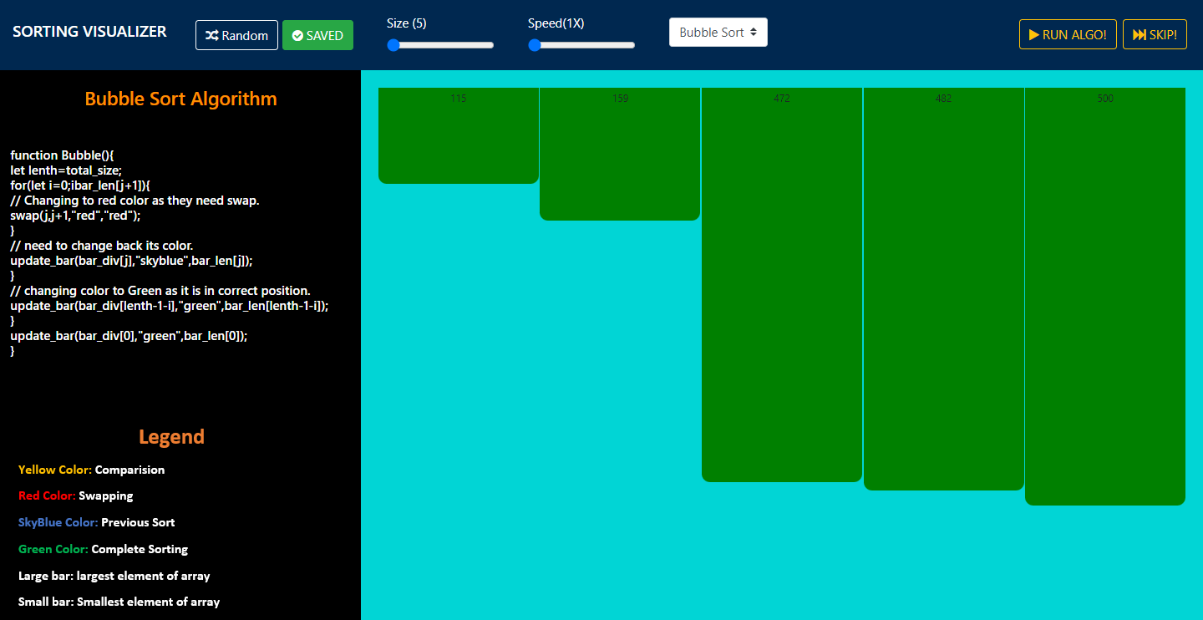

Fig 8.2.7 Successfully Sorted

**8.3 Insertion Sort**

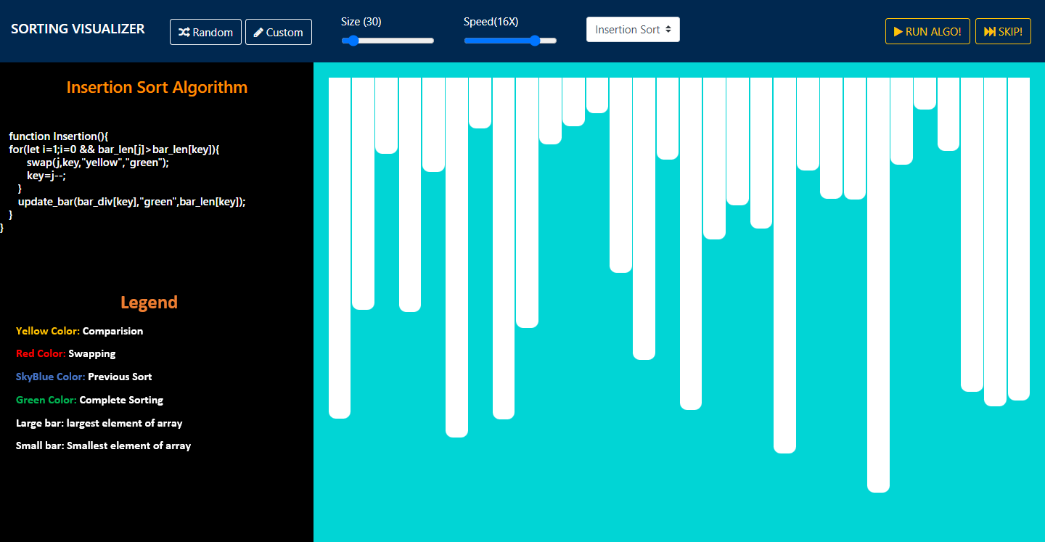

Fig 8.3 Insertion Sort

**8.4 Selection Sort**

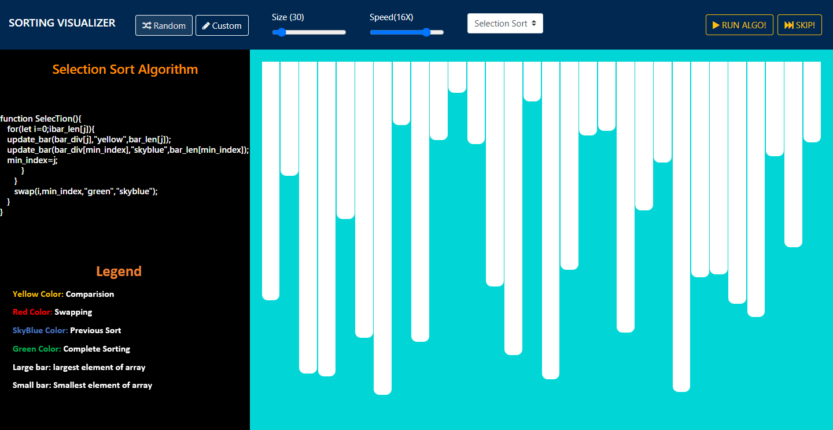

Fig 8.4 Selection Sort

**8.5 Quick Sort**

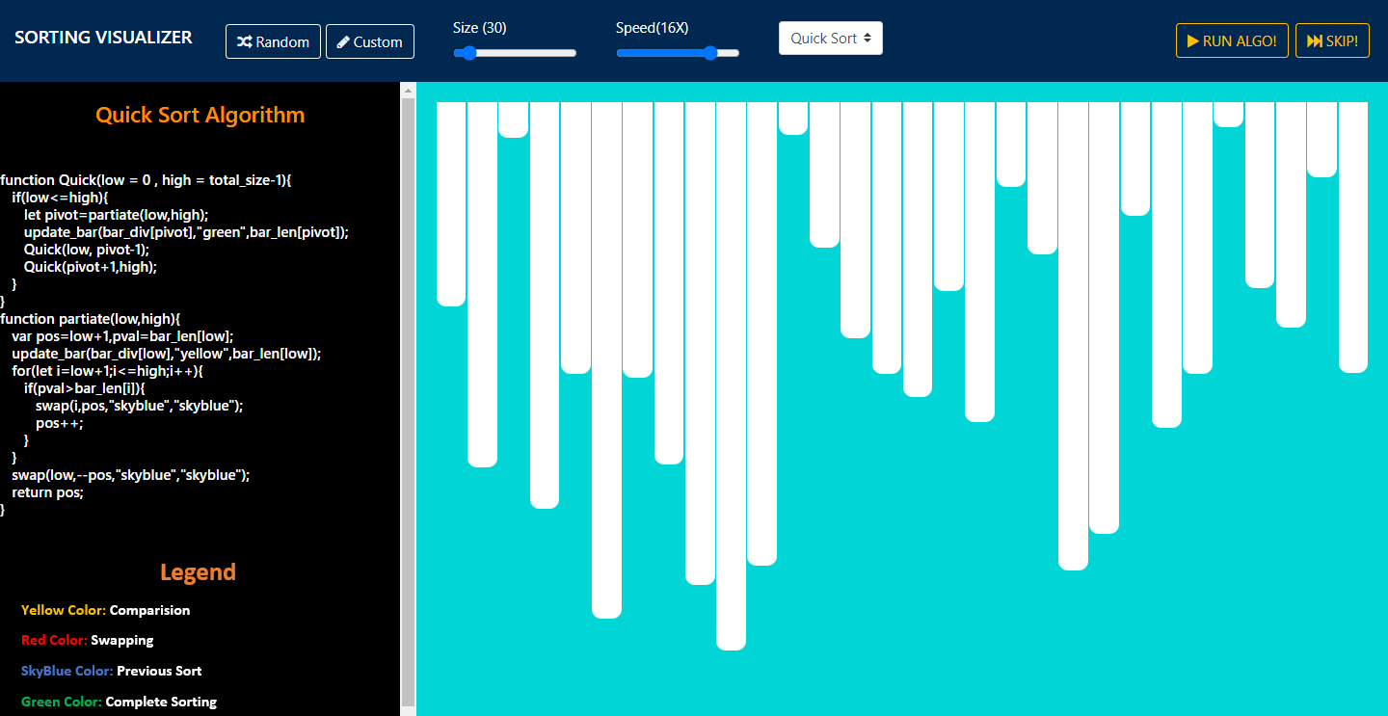

Fig 8.5 Quick Sort

**8.6 Merge Sort**

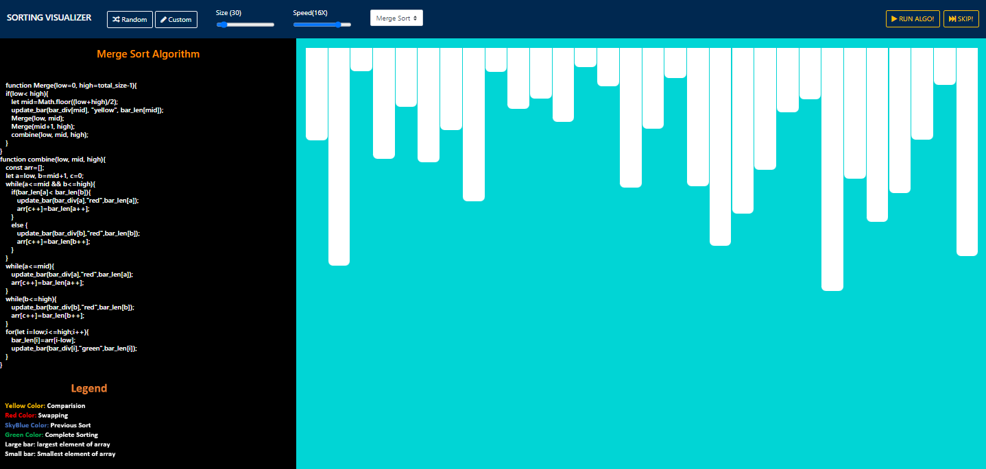

Fig 8.6 Merge Sort

# CONCLUSION

It is teaching support application which visualizes the most known sorting algorithms.

User run sorting algorithm by giving custom array. During the demonstration run, the application visualizes pseudo code and current information about some variables.

We tried to create high-quality software with a user-friendly and easy-to-use interface, which could be used by lecturers, tutors, and students. Possible next improvement of the applications is extension it by other algorithms.

# BIBLIOGRAPHY

* 1. D. Merlini, S. Petruzzi, R. Sprugnoli and M. C. Verri, "A system for algorithms' animation," Proceedings IEEE International Conference on Multimedia Computing and Systems, 1999, pp. 1033-1034 vol.2, doi: 10.1109/MMCS.1999.778649. <https://ieeexplore.ieee.org/document/778649>
  2. E. Vrachnos and A. Jimoyiannis, "DAVE: A Dynamic Algorithm Visualization Environment for Novice Learners," 2008 Eighth IEEE International Conference on Advanced Learning Technologies,2008, pp. 319-323, doi: 10.1109/ICALT.2008.148. <https://ieeexplore.ieee.org/document/4561697>
  3. Thakkar, Kavita, S. Dash and S. K. Joshi, "Sorting Algorithm visualizer," 2022 International Conference on Cyber Resilience (ICCR), 2022, pp. 1-5, doi: 10.1109/ICCR56254.2022.9996059. <https://ieeexplore.ieee.org/document/9996059>
  4. Goswami, A. Dhar, A. Gupta and A. Gupta, "Algorithm Visualizer: Its features and working," 2021 IEEE 8th Uttar Pradesh Section International Conference on Electrical, Electronics and ComputerEngineering (UPCON), 2021, pp. 1-5, doi: 10.1109/UPCON52273.2021.9667586. <https://ieeexplore.ieee.org/document/9667586>
  5. V. Karavirta and C. A. Shaffer, "Creating Engaging Online Learning Material with the JSAV JavaScript Algorithm Visualization Library," in IEEE Transactions on Learning Technologies, vol. 9, no. 2,pp. 171-183, 1 April-June 2016, doi: 10.1109/TLT.2015.2490673. <https://ieeexplore.ieee.org/document/7298430>
  6. B. R., R. V. and T. S., "Visualizing Sequence of Algorithms for Searching and Sorting," 2009 International Conference on Advances in Recent Technologies in Communication and Computing, 2009, pp. 647-649, doi: 10.1109/ARTCom.2009.20. <https://ieeexplore.ieee.org/document/5329052/authors>
  7. R. Smeulders and A. Heijs, "Interactive visualization of high dimensional marketing data inthe financial industry," Ninth International Conference on Information Visualisation (IV'05), 2005, pp. 814-817, doi: 10.1109/IV.2005.66.

<https://ieeexplore.ieee.org/document/1509166>

* 1. I. Reif and T. Orehovacki, "ViSA: Visualization of sorting algorithms," 2012 Proceedings ofthe 35th International Convention MIPRO, 2012, pp. 1146-1151 <https://ieeexplore.ieee.org/document/6240816>
  2. A. Yohannis and Y. Prabowo, "Sort Attack: Visualization and Gamification of Sorting Algorithm Learning," 2015 7th International Conference on Games and Virtual Worlds for Serious Applications (VS-Games), 2015, pp. 1-8, doi: 10.1109/VS-GAMES.2015.7295785. <https://ieeexplore.ieee.org/document/7295785>
  3. M. Marcellino, D. W. Pratama, S. S. Suntiarko and K. Margi, "Comparative of Advanced Sorting Algorithms (Quick Sort, Heap Sort, Merge Sort, Intro Sort, Radix Sort) Based on Time and Memory Usage," 2021 1st International Conference on Computer Science and Artificial Intelligence (ICCSAI), 2021, pp.154-160, doi: 10.1109/ICCSAI53272.2021.9609715. <https://ieeexplore.ieee.org/document/9609715>

32

